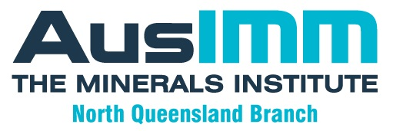

2022 ANNUAL GENERAL MEETING

11:30 am, Sunday, 4th December, 2022
Townsville Yacht Club, 1 Plume St., South Townsville

Committee Nomination Form 2023

Nominee: ...............................................................................................
AusIMM Membership Number if known ...............................................................
Contact Details for Committee Correspondence;
Email …………………………………………………………………….
Phone …………………………………………………………………….
Signed: ...............................................................................................
Date: ...............................................................................................

Supported by: ...............................................................................................
Signed: ...............................................................................................

Bring to AGM if attending, or return to: northqld@ausimm.com.au

