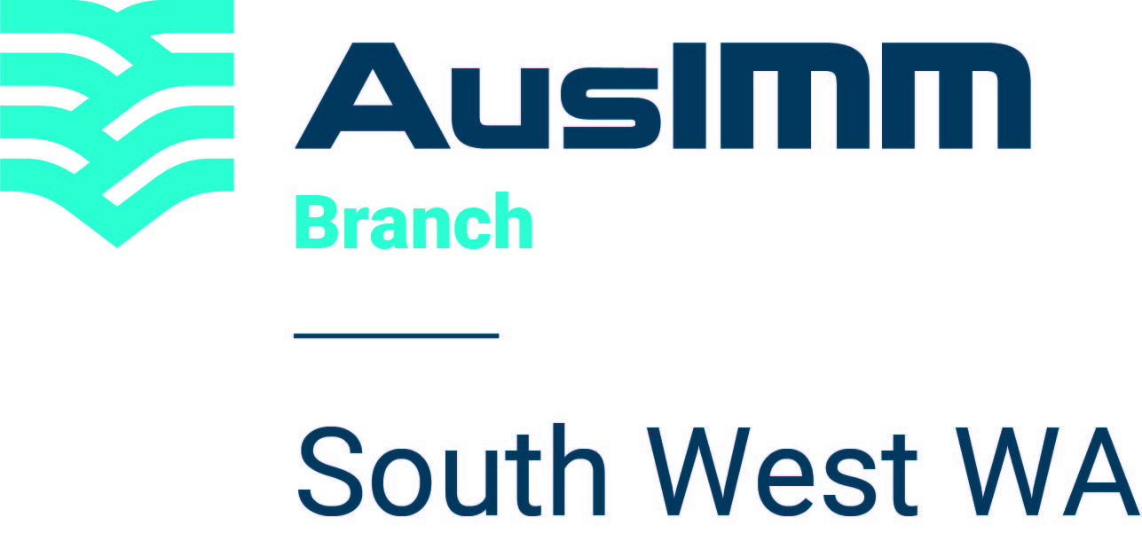
November 2026 Annual General Meeting
Eligibility and nomination process
• Only financial members may be nominated for committee positions. All nominations are confidential.
• Nominations are for the General Committee, not specific roles. Specific roles will be decided by the new committee at a later date.

NOMINEE DETAILS

Full name: | AusIMM member number:
Phone (mobile): | Phone (work):
Email: | Current occupation:
Optional: I am interested in holding the following position on the committee:
☐ AN EXECUTIVE ROLE  ☐ Chair  ☐ Vice-Chair  ☐ Treasurer  ☐ Secretary | ☐ A NON-EXECUTIVE ROLE  ☐ Events Sub-Committee Coordinator  ☐ Newsletter Coordinator  ☐ Social Media Coordinator  ☐ Community Relations Coordinator  ☐ Heritage Sub-Committee Coordinator  ☐ Education Coordinator  ☐ Other: Trusted Voice Ambassador  ☐ A General Committee Member Role
Nominee signature: | Date:
NOMINATOR DETAILS AND SUBMISSION
Please complete the nominator details below. If nominator details cannot be provided, the form may be completed and ratified at the AGM. The nomination form must still be emailed by 13 November 2026.

FIRST NOMINATOR DETAILS

Full name: | AusIMM member number:
Signature: | Date:
Contact details:
SECOND NOMINATOR DETAILS

Full name: | AusIMM member number:
Signature: | Date:
Contact details:
IMPORTANT DATES

Closing date | 12 noon, Friday 13 November 2026
AGM endorsement | Saturday 21 November 2026

EMAIL COMPLETED NOMINATIONS TO
SouthwestWA@ausimm.com

