Title of paper (use ‘Title’ style)

Author One1, Author Two2 and Author Three3 (initials and surnames only)

Note: Presenting author’s name should be underlined.

1. Position title, Organisation Name, City STATE Postcode, Country (if outside Australia). Email: names@company.com

2. Position title, Organisation Name, City STATE Postcode, Country (if outside Australia). Email: names@company.com

3. Position title, Organisation Name, City STATE Postcode, Country (if outside Australia). Email: names@company.com

Keywords: list keywords here

# ABSTRACT (USE ‘heading 1’ STYLE)

300 word abstract here…(Use ‘Body Text’ style)

Note: Do not use extra returns between paragraphs, or double spaces between sentences.

# introduction (USE ‘heading 1’ STYLE)

Text here… (Use ‘Body Text’ style)

Figures should be placed within the body of the paper right after being mentioned.

Crop images to best reflect subject matter.

Insert image, then apply ‘Image style’ formatting.

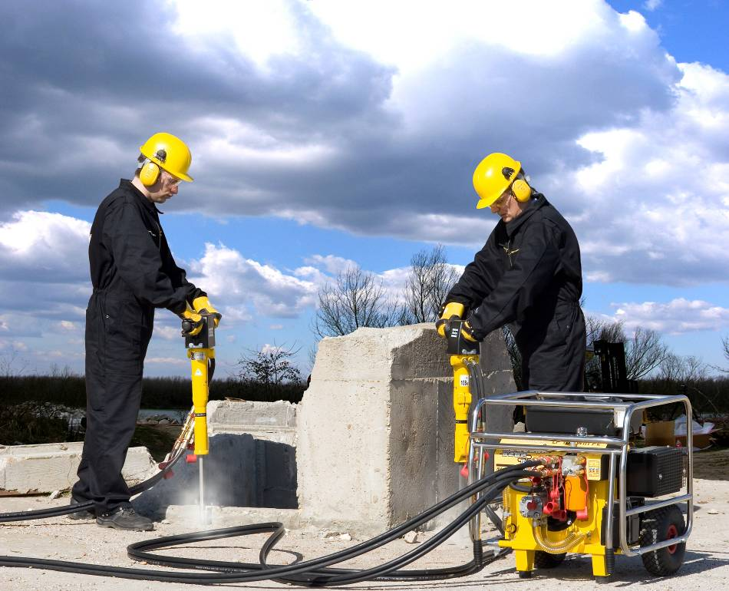

**FIG 1** – Caption …

Tables should be placed within the body of the paper right after being mentioned. Avoid tables being split across multiple pages (unless it is a large table).

TABLE 1

Caption …

|  |  |  |
| --- | --- | --- |
| Column 1 (Use ‘Table text header row’ style) | Column 2 | Column 3 |
| X (Use ‘Table text’ style’) | 10 | * 50 |
| Y | 20 | * 55 |
| Z | 20 | * 35 |

Table footnote.

# Next heading Level 1 (USE ‘heading 1’ STYLE)

Text here… (Use ‘Body Text’ style)

Other styles available to use:

* Bullets level 1
* Bullets level 2
* Bullets level 3

1. Numbers 1

Quotes

Equations (1)

Where:

Variables = descriptions

## Heading level 2 (Use ‘Heading 2’ style)

Text here… (Use ‘Body Text’ style)

### Heading level 3 (Use ‘Heading 3’ style)

Text here… (Use ‘Body Text’ style)

#### Heading level 4 (Use ‘Heading 4’ style)

Text here… (Use ‘Body Text’ style)

##### Heading level 5 (Use ‘Heading 5’ style)

Text here… (Use ‘Body Text’ style)

# CONCLUSIONS (USE ‘heading 1’ STYLE)

Text here… (Use ‘Body Text’ style)

# ACKNOWLEDGEMENTS (USE ‘heading 1’ STYLE)

Text here… (Use ‘Body Text’ style)

Note: please acknowledge collaborators here or anyone who has helped with the paper. It may also be appropriate to acknowledge company approval to publish.

# REFERENCES (USE ‘heading 1’ STYLE)

List references here (Use ‘Reference List’ style)

Note: List references alphabetically by author surname. **Do not use a numbered list**. Refer to the AusIMM Guide to Authors for further instructions and information about the correct formatting of references. Do not provide a Bibliography.