Title of extended abstract (use ‘Title’ style)
Author One¹, Author Two² and Author Three³ (initials and surnames only)
Note: Presenting author’s name should be underlined.
1.Position title, Organisation Name, City State Postcode. Email:
2.Position title, Organisation Name, City State Postcode. Email:
3.Position title, Organisation Name, City State Postcode. Email:
…etc
Keywords: list keywords here

introduction (USE ‘heading 1’ STYLE)
Text here… (Use ‘Body Text’ style)
Note: please start your extended abstract here (up to 1000 words). Do not include a separate abstract.
Figures should be placed within the body of the extended abstract soon after being mentioned.
Crop images to best reflect subject matter.
Insert image using ‘Image style’
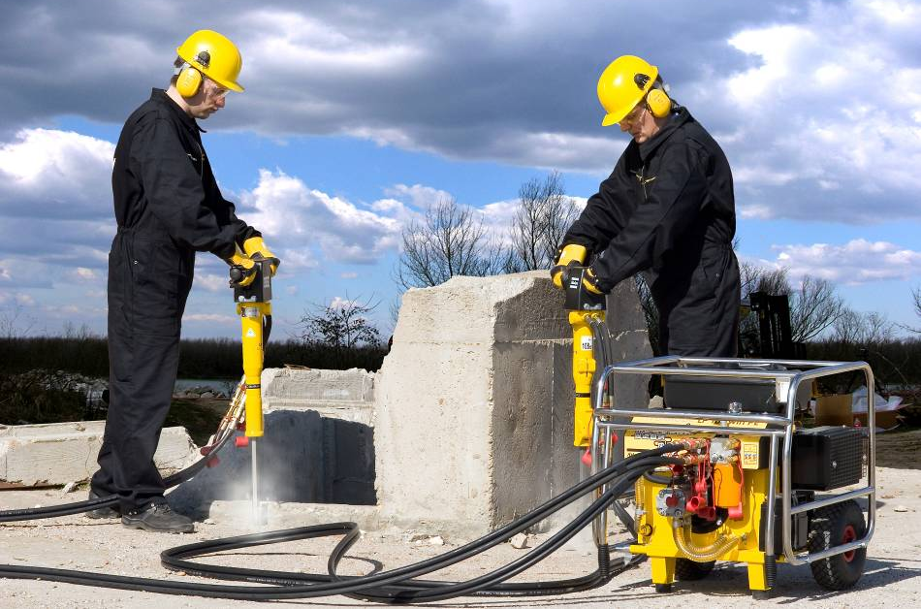
FIG 1 – Caption …
Tables should be placed within the body of the extended abstract soon after being mentioned.
Column 1 (Use ‘Table text header row’ style) | Column 2 | Column 3
X (Use ‘Table text’ style’) | 10 | 50
Y | 20 | 55
Z | 30 | 62
X | 40 | 50
Y | 60 | 50
Z | 20 | 35
x | 15 | 10
TABLE 1 – Caption …

ACKNOWLEDGEMENTS (USE ‘heading 1’ STYLE)
Text here… (Use ‘Body Text’ style)
Note: please acknowledge collaborators here or anyone who has helped with the extended abstract. It may also be appropriate to acknowledge company approval to publish.

REFERENCES (USE ‘heading 1’ STYLE)
List references here (Use ‘Reference List’ style)
Note: Note: this is not mandatory and should be included only if necessary.
List references alphabetically by author surname. Do not use a numbered list.

